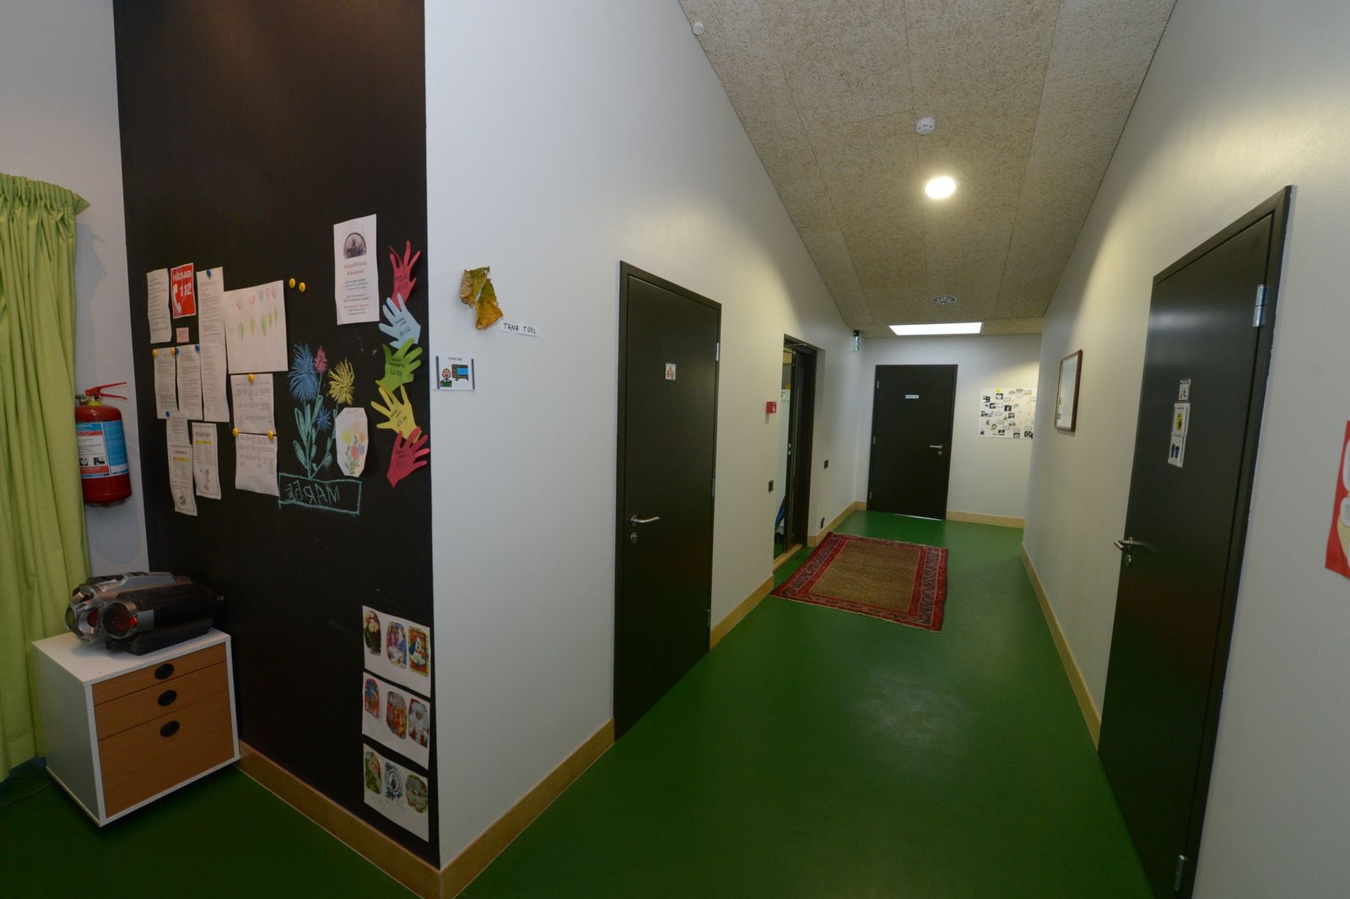

So Close, Yet So Far

An analysis of the extent to which the Estonian care villages for people with intellectual disabilities and mental health conditions comply with the Common European Guidelines on the Transition from Institutional to Community-based Care

European Network on Independent Living
October 2017
Acknowledgments
This paper was written by Mari Siilsalu and Jamie Bolling, and edited by Ines Bulic Cojocariu.
Ms. Mari Siilsalu, based in Sweden, is a law student at the Open University UK. She has worked as a peer-counsellor and campaigner on Independent Living in Estonia, and has focused on deinstitutionalization and inclusion of young disabled people.
Mrs. Jamie Bolling, based in Sweden, was the Executive Director of the European Network on Independent Living (ENIL) between 2009 and September 2017, and is currently the Executive Director of the Independent Living Institute (ILI) in Stockholm. She was a member of the EU Fundamental Rights Platform’s Advisory Panel from 2010 until 2014 and has been a co-chair of the European Expert Group on the Transition from Institutional to Community- based Care (EEG) from September 2016 until July 2017. Jamie has an MA degree in social anthropology and experience in disability research and international development cooperation.
Cover photo: Postimees (2013) Gallery: ‘Opening of a family village for people with special needs (Galerii: Vääna-Vitil avati erivajadustega inimestele pereküla)‘. Available at: http://www.postimees.ee/2578404/galerii-vaeaena-vitil-avati-erivajadustega-inimestele-perekuela

For more information, please contact:

ENIL Brussels Office
Mundo J – 7th Floor
Rue de l’Industrie 10
1000 Brussels
Belgium
E-mail: ines.bulic@enil.eu
Web: http://www.enil.eu

Terminology
Community-based services | Services which are provided for disabled people within the mainstream community and facilitate the social inclusion of disabled people.
Round-the-clock service | Includes care provision, developmental activities and support for 24 hours a day, where accommodation and meals are part of the service.
Service unit | The number of service places within an independent household. For example, a care village is one service unit.
AS Hoolekandeteenused | A fully state-owned company, which operates all of the care villages.
SA Hea Hoog (SAHH) | A foundation specialised in finding and creating jobs for disabled people, as well as marketing the products made by disabled people. The main purpose of the organisation is to find employment for the service users of AS Hoolekandeteenused.

1. Introduction
The European Union aims to contribute to smart, sustainable and inclusive growth by investing a substantial amount of the European Structural and Investment Funds (ESI Funds) into social care, employment, education and other fields in the Member States. More specifically, one of the aims of the current ESI Funds programming period is to support deinstitutionalisation - the transition from long-stay residential institutions to community-based support services. This means that those who live in the long-stay residential institutions should have the opportunity to leave and benefit from support services in the mainstream society, thus becoming more included in the community life. Preventing the entry of disabled people into institutions is another important aspect of deinstitutionalisation.
This article has been written for the European Network on Independent Living (ENIL) on the occasion of the Estonian Presidency Conference on deinstitutionalisation on 12 - 13 October 2017. Its aim is to discuss whether Estonian care villages for people with intellectual disabilities and mental health conditions are a form of community-based services or whether they continue to provide institutional care. In the first part of the article, the characteristics of an institution, as set out in the Common European Guidelines on the Transition from Institutional to Community-based Care, are presented. Thereafter, the daily life in the care villages is briefly described, followed by a comparison between the care villages and the characteristics of an institution. Based on this comparison, the concluding chapter argues that the Estonian care villages are institutions and therefore fail to facilitate real deinstitutionalisation in the country.
1.1 Estonia’s deinstitutionalisation strategy
According to Estonia’s Operational Programme for Cohesion Policy Funds for 2014 - 2020, gradual deinstitutionalisation was first set out as a goal in 2006, in a strategy entitled the ‘Reorganisation of State Owned Special Care Institutions and Services Plan’. Based on this document, Estonia has been implementing deinstitutionalisation reforms since 2007. The strategy for the most recent phase of deinstitutionalisation in Estonia, funded with combined investments from the European Social Fund (ESF) and the European Regional Development Fund (ERDF), is set out in the ‘Special Welfare Development Plan for 2014 - 2020’. As part of this process, Soviet-era long-stay residential institutions for adults with intellectual disabilities and mental health conditions receiving the round-the-clock service will be reorganised and/or closed by 2023.
Most of the people living in such institutions have not had any experience of dealing with everyday life outside the institutional environment, because they have been institutionalised for decades and never had the opportunity to gain the skills needed to live independently. For this reason, they are considered as difficult to include in the community, given that they need more personalised support than what the community-based services in Estonia can offer. Thus, care villages consisting of around 6 family houses with about 10 persons with intellectual disabilities and mental health conditions in each house are being built as a transitional service. These houses are meant to help former residents of the Soviet-era institutions in their transition to community-based support services.
During the 2007-2013 programming period, a total of 550 service places were created in ‘family-type’ care settings, such as care villages for people with intellectual disabilities and mental health conditions. According to Atonen, another 1,400 service places in care villages, as well as in other types of service units, such as, for example, shared flats for people with intellectual disabilities and mental health conditions, are to be created by 2023. The planned investment from ESF and ERDF, between 2014 and 2020, is 47.6 million Euros.
The goals for the current ESI Funds programming period are even more ambitious than for the previous one. The planned number of ‘family-type’ houses within each care village will vary. Unlike in the previous programming period, only projects for care settings for up to 30 persons will receive funding, which means that the future service units will be somewhat smaller than the ones built between 2007 and 2013. Just like during the previous programming period, residents in each service unit will be divided into ‘family-like’ groups, with a maximum of 10 persons per setting (for example, family houses for up to 10 persons). The only difference is going to be the number of ‘family-like’ groups in each service unit. For example, Tartu Postimees reports that there is a plan to open a new care village in Tartu, with 50 service places, which includes 3 family houses with 10 persons each, by the end of 2018.
2. The defining characteristics of an institution
This chapter briefly describes some of the characteristics of an institution, based on the Common European Guidelines on the Transition from Institutional to Community-based Care (further referred to as ‘EEG Guidelines’).
EEG guidelines were written by the European Expert Group on the Transition from Institutional to Community-based Care (EEG), a broad coalition of stakeholders which aims to assist the European Commission and the Member States in deinstitutionalisation. They were published in 2012, with detailed suggestions on how the transition from long-residential institutions to community-based services should be carried out at the national level.
EEG Guidelines define an institution as residential care where:
- Residents are isolated from the broader community and/or compelled to live together;
- Residents do not have sufficient control over their lives and over decisions which affect them; and
- The requirements of the organisation itself tend to take precedence over the residents’ individual needs.

Additionally, a crucial part of moving away from institutional settings is abandoning the ‘institutional culture‘. According to the ´Report of the Ad Hoc Expert Group on the Transition from Institutional to Community-based Care´, the main elements of ‘institutional culture’ are:
- depersonalisation,
- fixed timetable for daily routines and activities,
- processing people in groups rather than individually,
- social distance between the staff and the residents.

This means that a care setting where the ‘institutional culture‘ persists, or where residents are treated in the way described above, can still be considered an institution.
3. Daily life in the Estonian care villages
The following chapter describes the daily routine of Estonian care villages and ends with a short case study of the three care villages.
3.1 Size
According to Päeske, an average Estonian care village consists of 6 family houses with 10 service places per family house. The group of residents in the house is often referred to as ‘a family’. Each bedroom has 1-2 beds for each resident (referred to as ‘customers’). As most of the residents have their own room, they can choose how to decorate it.
3.2 Location
The geographical location for the care villages has been chosen to be close enough to a village or a town, so that everything the residents might need would be available to them. Having a number of care villages in different locations aims to give the residents a choice of where they want to live. Some might choose a location because it is near their home, or because they are connected to it through a past event or experience. However, according to the 2015 AS Hoolekandeteenused Annual report, the two largest cities in Estonia - Talinn and Tartu - have a total of 80 service places. This includes 30 service places in Tallinn and 50 service places in Tartu, and does not include any round-the-clock service places. On the other hand, some villages with a much smaller population, such as Sinimäe (60 service places) and Vääna-Viti (90 service places), have altogether 125 round-the-clock service places.
3.3 Staff numbers
There are slightly more personnel per resident in the new care villages than there were in the Soviet-era long-stay residential institutions. Statistics show that each occupational therapist works with 2.9 residents in a care village, as opposed to 3.3 residents in a Soviet-era long-stay residential institution. Although, to some extent, residents receive more support, the type of support has not changed- residents do not receive more personal assistance or any other community-based support service in the care villages.
3.4 Activities
According to the AS Hoolekandeteenused 2015 Annual report (referred to as the ´Annual report 2015´), the residents attend a wide range of different activities designed to keep them healthy and busy. The main guiding principle for everyday life in all care villages is: “A more active way of life. (Tegusama elu kodud.)”. The residents are to be offered every opportunity for a more active and varied life within the community. However, the entire care village follows a fixed weekly and daily timetable, with stipulated activity per hour, and rules decided by the personnel. Furthermore, each resident has an individual daily plan, which includes an agenda for different activities for each day.
In terms of having active free time, the Annual report 2015 states that there are cultural and entertainment events organized in each care village and jointly between different care villages. In addition, some care villages point out that their residents are active members of the community and like to visit shopping malls, concerts, churches etc. Another guiding principle in the care villages is promoting the residents’ healthy lifestyle. Therefore, an hour of exercise is added into the daily plan of each resident. There are also sports events organised for the residents, such as the “Winter Sport Day (Talispordipäev)”.
The Annual report 2015 explains that there are ‘activity centres (tegelusmajad)’ in the near vicinity of each care village. In effect, these are sheltered workshops for the residents who work there, as well as learn skills such as cooking food or doing handicraft. According to Päeske, in addition to the activity centres, residents can work in the open labour market or through the SA Hea Hoog (SAHH) initiative, created by AS Hoolekandeteenused. As a result, the number of people in employment has increased - in the Soviet-era long-stay residential institutions it is 14%, as opposed to 25,2% in the care villages. These percentages include both people working within the care villages or within the Soviet-era long-stay residential institutions, as well as outside (either in the activity centres or the actual mainstream work places). A total of 16,2% of all residents of the care villages actually leave the care village to go to work, which means that about one third (9%) of the residents who work, do so without leaving their care village.
4. Three case studies of the Estonian care villages
Vääna-Viti Home consists of 90 residents accommodated in a mansion house and 5 family houses. The residents are supervised by 25 occupational therapists and 2 senior occupational therapists. The stated guiding principle for everyday life in the Vääna-Viti Home is ensuring the individual approach to each resident and helping each resident become an active citizen, valued in the community. At the same time, the Vääna-Viti Home has a daily plan with a fixed hourly activity timetable, which all the residents must follow. These include meal times, hours to wake up and go to bed.
Picture: Daily plan for residents living in a family house in Vääna-Viti
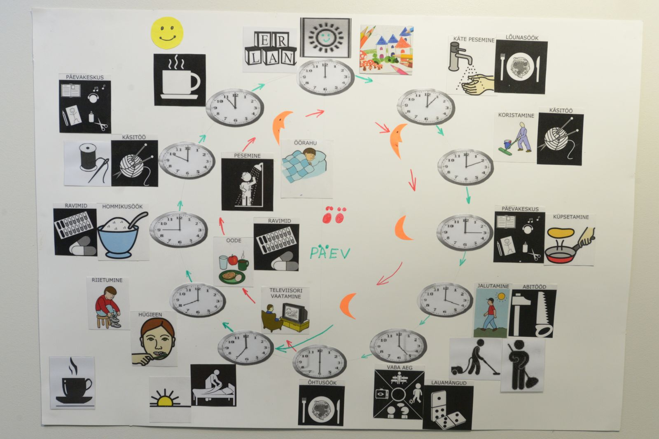

Sinimäe Home is a care village of 6 family houses for 60 persons. The residents are supervised by 22 occupational therapists. A promotional video for the Sinimäe Home refers to it as “a little home for 60 persons”. The daily and weekly plan, including a fixed hourly timetable, are published on the home’s website, as are the home rules (kodukord) and rules for the visitors (külastamise kord). Examples of rules in the Sinimäe care village are set out below, in order to gain some understanding of how the residents and their visitors are expected to behave.
One of the rules (No 6) reads as follows: “I follow the daily plan of the Home/---/ During the night I stay in the Home (Ma hoian Kodu päevakorrast kinni/---/ Öisel ajal viibin Kodus)”. Another rule (No 9) states: “I know that on the territory of the Home it is prohibited to consume alcohol/---/ (Ma tean, et Kodu alal on keelatud alkoholi tarbimine/---/)”.
The second subsection of the home rules is ‘My Home order’ (minu Kodu kord). Under this subsection, the first rule is: “If agreed with the occupational therapist, I can use my own things in my own room: the television, radio and other technical equipment, as well as furniture (Kokkuleppel tegevusjuhendajaga võin kasutada omas toas enda asju: televiisorit, raadiot ja muud tehnikat, samuti mööblit).” The fourth rule explains: “If agreed with the occupational therapist, I have an option to use the Home’s telephone 10 minutes per week (Kokkuleppel tegevusjuhendajaga on mul võimalus kasutada Kodu telefoni 10 minutit nädalas).”
The third subsection of the home rules is ‘Responsibility’ (vastutus). The second rule states: “I am aware that the Home can end the contract with me before it has expired, if I break the rules more than once. (Olen teadlik, et mitmendat korda korra rikkumisel võib Kodu minuga lepingu lõpetada enne tähtaega.)”. Thus, breaking the Home’s rules may result in serious consequences, such as termination of the contract. It is unclear what support is available to those who do not follow the rules and lose their contract with the Sinimäe Home.
Rules for visiting the care village note, for example, that the visiting hours are from 10.10 until 18.00, which means that the residents can host guests only during these given hours.
Tapa Home is a care village of 6 ‘family houses’, with 60 service places in total. Each ‘family house’ acts as an activity centre for the whole village – one organises handicraft activities, while the others put on sports, musical, drawing and painting activities, activities for the development of academic skills and motoric activities. Each resident’s daily plan states which activities, in which ‘family house’, s/he is participating in. This means that, in addition to a daily timetable for the whole ‘family house’, each resident follows a personal plan of the above mentioned occupational activities. Residents also work in the work centre (a sheltered workshop), which is located in town.
5. Estonian care villages: Deinstitutionalisation or reinstitutionalisation?
The aim of this chapter is to establish whether the Estonian care villages have any of the characteristics of an institution, as outlined in the EEG Guidelines. As a result, we will be able to conclude whether they facilitate deinstitutionalisation, or help to continue the practice of segregating and excluding people with intellectual disabilities and mental health conditions from the Estonian society.
Institutional characteristic No. 1: People are compelled to live together, while separated from the rest of the society
Even though it has been argued by Päeske that the residents’ choices have been taken into consideration, it is unlikely that, for example, 10 persons in the 6 houses (altogether 60 persons) have made an informed decision to live together. Therefore, it is highly probable that with such a high number of residents in the care villages, they have, at least to a certain degree, been compelled to live together.
Moreover, a care village of ‘family houses’ forms a campus – accommodating exclusively disabled people and the personnel - separated from the mainstream community. Such conditions contribute to creating a distance between the residents of the care villages and the mainstream society.
Employment schemes, where the residents work in activity centres near their care village or, more worryingly, inside the care village, further separate them from the mainstream labour market, as well as from the community in general.
Institutional characteristic No. 2: Residents have limited choice and control over their lives, and the rules of the organisations tend to overrule the residents’ personal needs
As explained earlier, Päeske argues that the geographical location of the care villages has been carefully chosen, with the aim of ensuring that the residents are able to choose where they want to live and that they have access to everything they need. However, a large number of service places have been created near smaller villages, as opposed to bigger cities, which do not offer any round-the-clock service places at all. Therefore, those in need of the round-the-clock service are compelled to live away from bigger cities in a campus setting, with a disproportionally high number of other residents, compared to the overall size of the community.
The care village residents follow a set hourly plan for their care village and their house, as well as an individual plan which they have not fully decided on by themselves. In addition to these daily plans, the residents must follow the house rules, which set extremely strict expectations on their behaviour and therefore limit their self- determination and spontaneous behaviour – something that is taken for granted by the rest of the adult population. For example, according to the house rules, even during the hours allocated for activities, residents need permission from the occupational therapist to use the kitchen or the home’s telephone. Some activities, which are normal for adults, such as consuming alcohol and being outside during the night, are completely prohibited. There are sanctions outlined for those residents who do not follow these rules.
Thus, while the residents are supported by the staff and may take some decisions in their daily life (for example, what their room looks like), there remains a fixed structure for keeping them busy and ‘out of the harm’s way’, with the individual person having little or no control over this structure. This is inconsistent with the guiding principle of providing a more active life for the residents, which should include more responsibility and an opportunity to take risks.
The services provided in the ‘family houses’ do not follow the resident, if s/he should decide to move or to visit family, for example. Therefore, the person in need of support cannot choose where to live. Even though each resident has a personal plan, the plan is tied to housing. It is implemented in the care village setting, with fixed on-site services, including meals, as well as care. Therefore, the personalised plan has a limited effect when implemented in a depersonalised care structure, where the possibilities for providing services, which would allow for choice and control, are nearly non-existent.
In order to determine the level of self-determination involved in the residents’ free time, there is a need for more information on whether the residents initiate activities themselves or not. For example, it would be important to know who decided on having an hour of sports in the daily plan for each resident, to what extent they were consulted, and whether they could decide which sports activity they take part in.
Additionally, it is unclear to what extent the care village residents can choose their job, workplace and whether the working conditions suit them or not - in the same manner as non-disabled people choose their employment. Additionally, it would be important to know, for example, whether the residents are compensated for the work they do (or whether they work for free or for a lower than average payment), if reasonable accommodations have been made by the employer and if they work alongside non-disabled people, or in sheltered employment. Depending on the answers to these questions, we would be able to conclude if the Estonian care villages are successful in supporting disabled people into the labour market.
Institutional characteristic No. 3: People are processed in groups and tend to be depersonalised by members of staff
Individual approach is limited in the care villages, as the service provider’s focus is on the number of service places created and not on people themselves. In addition, not enough attention is paid to the creation of services which are flexible enough for individualised support, and are based on the unique preferences and needs of each individual. The residents are organised into different groups and receive block treatment from the personnel. For example, there is a weekly and daily timetable with a set schedule, including the group activities each resident attends during the weekdays (as described in the example of the Tapa home).
As the day is planned for each resident and there are rules for expected behaviour, there is little room for personal preferences. This suggests that, overall, the residents are expected to act alike and not develop personal patterns of behaviour and habits, which may conflict with the structure of the organisation.
Moreover, it is important to note that for everything they do, the residents have to get permission from the staff. Therefore, the status of a staff member seems to be superior to that of a resident.
Finally, referring to the group of 10 persons in one ‘family house’ as ‘a family’ is an artificial indication of them as a group that belongs together; this taking into consideration that the average family in Estonia has statistically only 2,74 members.
Conclusions and recommendations
The ‘Report of the Ad Hoc Expert Group on the Transition from Institutional to Community- based Care’ notes that an institution of any type is contrary to the aims of deinstitutionalisation. According to Bugarszki and others, the Estonian care villages were planned to facilitate deinstitutionalisation, but are still segregated institutions. This is because service users do not have a real freedom of choice and there are very few things they can decide on, in terms of the support they receive and their life situation.
Having used the EEG Guidelines to establish whether the Estonian care villages have any of the characteristics of institutional care, this paper has come to the same conclusion. This implies that, in 2017, in the middle of the 2014 - 2020 ESI Funds programming period, Estonia has made insufficient progress in reaching its objective on ‘the transition from institutional to community-based care’.
In order to ensure that Estonia acts in compliance with the UN Convention on the Rights of Persons with Disabilities (CRPD), especially Article 19 (Living independently and being included in the community) and the General Comment No 5, the following actions should be taken:
- It is key that, during the current ESI Funds programming period, Estonia does not use EU Funds (or any other funding) to build more care villages. Regardless of the size of the villages, or their so-called ‘transitional’ nature, it is likely they will preserve many of the characteristics and practices from the old Soviet-era long-stay residential institutions.
- There is an urgent need for significant changes in the Estonian deinstitutionalisation strategy, which would ensure that the care villages are replaced with sufficient accessible and affordable housing in the community and other community-based services, in line with Article 19 CRPD. This would allow Estonia to successfully complete the deinstitutionalisation process by 2023.
- While the care villages may be presented as a transitional measure between the Soviet-era long-stay residential institutions and life in the community, it is unclear how long the transition period is and how all the residents will be supported to live in the community. While the residents may gain some useful skills in the care villages, their need for personalised support, adequate housing, access to mainstream services and facilities remains. It is questionable what resources will be available to provide such support and other services, given how much funding was (and will be) invested into the care villages.
- Facilitating self-determination of disabled people is one of the vital preconditions of a successful deinstitutionalisation process. Such self-determination cannot be achieved in a care village for 60 persons, where decisions must be made for the sake of maintaining the overall order. Under such conditions, allowing for different lifestyles and daily activities in accordance with the preferences of each individual is impossible. For this reason, any future deinstitutionalisation strategy must provide for real choice in relation to housing and support, for measures that facilitate social inclusion, and for the use of peer support to help the individuals’ transition from institutional care to living in the community.

According to the Common European Guidelines on the Transition from Institutional to Community-based Care, the term ‘community- based services’ refers to services which are provided for disabled people within the mainstream community and facilitate the social inclusion of disabled people. (European Expert Group on the Transition from Institutional to Community-based Care, 2012, p. 27)
European Expert Group on the Transition from Institutional to Community-based Care (2014), Toolkit on the Use of European Union Funds for the Transition from Institutionl to Community-based Care, p. 21. Available at: http://enil.eu/wp-content/uploads/2016/09/Toolkit-10-22-2014-update-WEB.pdf
ENIL prefers the term ‘disabled people’ over ‘persons with disabilities’ or ‘people with disabilities’, in order to reflect the fact that people are disabled by the environmental, systemic and attitudinal barriers in society, rather than by their impairment. This is in line with the social model of disability.
European Expert Group on the Transition from Institutional to Community-based Care (2012), Common European Guidelines on the Transition from Institutional to Community- based Care. Available at: http://enil.eu/wp-content/uploads/2016/09/Guidelines-01-16-2013-printer.pdf
Estonian Ministry of Social Affairs, Riiklike erihoolekandeasutuste ja –teenuste reorganiseerimise kava. Available at: https://www.sm.ee/sites/default/files/content-editors/eesmargid_ja_tegevused/Sotsiaalhoolekanne/Puudega_inimetele/riiklike_erihoolekandeasutuste_ja_-teenuste_reorganiseerimise_kava.pdf
Estonian Ministry of Social Affairs, Erihoolekande arengukava aastateks 2014-2020. Available at: https://www.sm.ee/sites/default/files/content-editors/eesmargid_ja_tegevused/Sotsiaalhoolekanne/Puudega_inimetele/erihoolekande_arengukava_2014-2020.pdf
The ‘round-the-clock service’ includes care provision, developmental activities and support for 24 hours a day, where accommodation and meals are part of the service. (Päeske, Integration of the round-the-clock service special care clients to society on the example of AS Hoolekandeteenused, 2015, 1.1.)
Päeske, 2015, Integration of the round-the-clock service special care clients to society on the example of AS Hoolekandeteenused.
Ministry of Finance of the Republic of Estonia s. 2.2. Available at http://www.struktuurifondid.ee/public/EE_OP_EN_2_12_2014.pdf
Atonen (2016), ‘Erihoolekande taristu arendamine (Developing the infrastructure for special care)’ Sotsiaaltöö 1/2016). Available at: http://www.tai.ee/images/ST1_2016_sisu_Atonen.pdf
A service unit is the number of service places within an independent household. For example, a care village is one service unit. (Atonen, 2016)
Atonen, 2016.
Tartu Postimees (2016), ‘Tartu Ehitab Neli Uut Peremaja (Tartu builds Four New Family Houses)’. Available at: http://tartu.postimees.ee/3811473/tartu-ehitab-neli-uut-peremaja
For more information about the EEG, see https://deinstitutionalisation.com
EEG Guidelines, p. 5.
EEG Guidelines, p 10.
European Commission (2009), Report of the Ad Hoc Expert Group on the Transition from Institutional to Community-based Care, p. 9.
Päeske, 2015, 2.3
AS Hoolekandeteenused ‘Aastaraamat 2015 (Year-book 2015)’ see p. 50- 95. Available at: http://www.hoolekandeteenused.ee/pages/valisveeb/ettevottest/aruanded.php
Päeske, 2015, 2.3
Päeske, 2015, 1.2
AS Hoolekandeteenused is a fully state-owned company, which operates all of the care villages, which are described and analysed in this article (AS Hooekandeteenused Annual report 2015, p. 5)
AS Hoolekandeteenused, 2015, p. 48-95
Päeske, 2015, 2.3.
AS Hoolekandeteenused ‘Majandusaasta Aruanne 2015 (Annual Report 2015)’, p. 25-36. Available at: http://www.hoolekandeteenused.ee/media/valisveeb/Aruanded/HKT_majandusaasta_2015_Aruanne_10399457.pdf
Ibid, p. 28-29.
SA Hea Hoog (SAHH) is a foundation, specialised in finding and creating jobs for disabled people, as well as marketing the products made by disabled people. The main purpose of the organisation is to find employment for the service users of AS Hoolekandeteenused. See: http://www.hoolekandeteenused.ee/pages/eng/about-us/hea-hoog.php
Päeske, 2015, 2.3
AS Hoolekandeteenused website: http://www.hoolekandeteenused.ee/vaana/
Ibid.
“Sinimäe kodu linnulennult (Sinimäe home seen from above)” [In Estonian] Available at http://www.hoolekandeteenused.ee/sinimae/. The first part of the video shows footage of Sinimäe village (Sinimäe alevik), followed by the Sinimäe Home (Sinimäe Kodu) ’family-type’ homes.
AS Hoolekandeteenused website: http://www.hoolekandeteenused.ee/sinimae/
Ibid.
Statistics Estonia database (Statistikaamet)
European Commission (2009), Report of the AdHoc Expert Group on the Transition from Institutional to Community-based Care, p. 11.
‘Uuring psüühilise erivajadusega inimestele suunatud erihoolekandesüsteemi ümberkorraldamiseks ja tõhustamiseks teiste riikide praktikate alusel (Research for reorganisation and improvement of special care services on the basis of practices from other countries)‘ p. 6.
See General comment No 5 on Article 19, cited in European Network on Independent Living (2017) `ENIL Welcomes UN Key Guidance on the Right to Independent Living`. Available at: http://enil.eu/news/enil-welcomes-key-un-guidance-right-independent-living/

